**Name: Ahmed Emad Mohamed Kamel**

**ID: 111**

**Group: 1**

**Sction**: **5**

**Topic:** Database Systems

**Application Brief:**

I chose this topic because data storage for all sites depends on it.

**GitHub-Link:**

**GitHub-Page(Published Website):**

**Screenshots:**

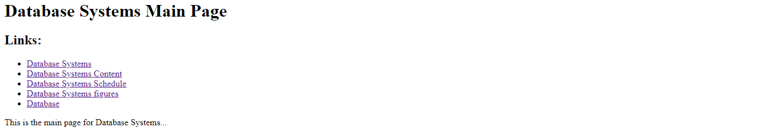

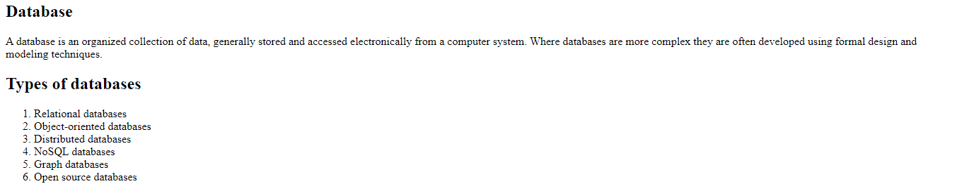



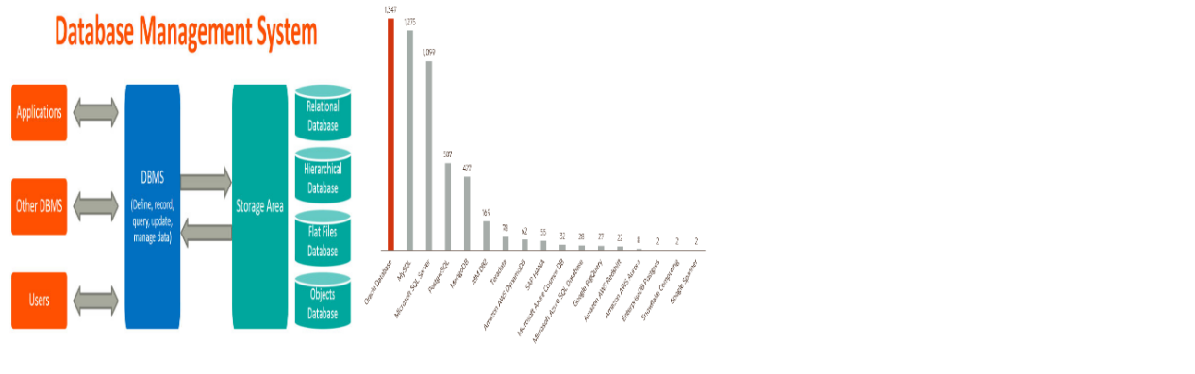

**Source Code:**

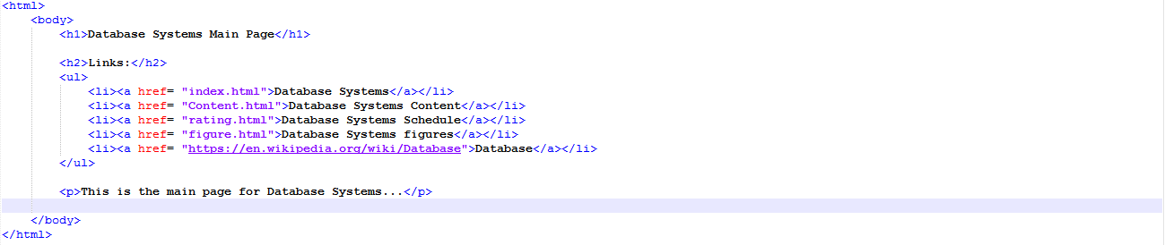

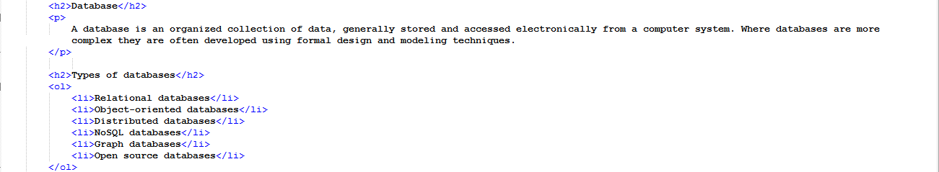

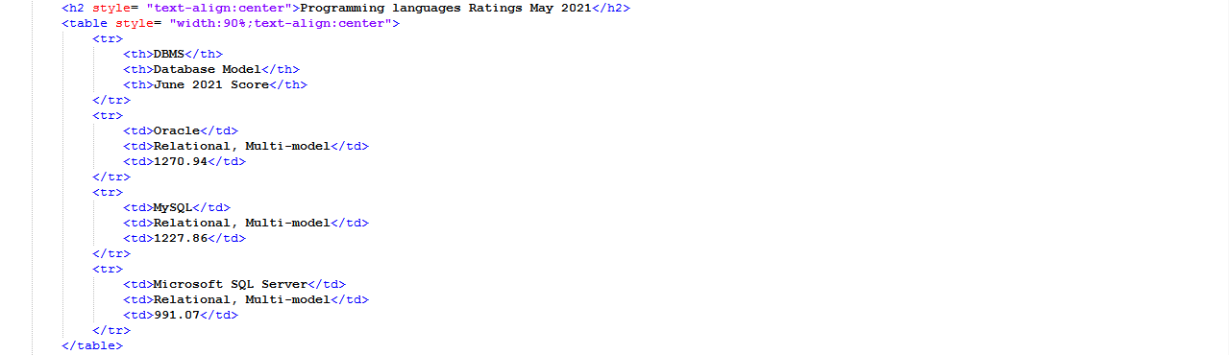

8